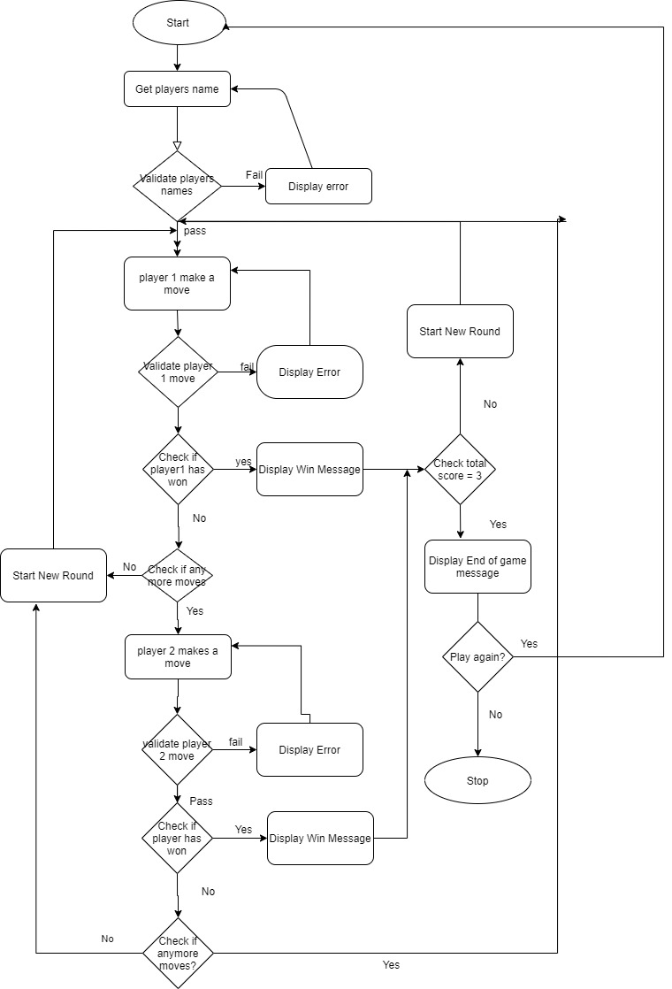

|  |  |  |  |
| --- | --- | --- | --- |
| **TIC TAC TOE TEST CASES** | | | |
| S  /no. | Test Case | Expected Result | Actual Result |
| 1 | Enter name of game | Display welcome screen |  |
| 1 | Enter Empty Name | Display Error |  |
|  | Enter valid name | Display next step |  |
| 2 | Enter duplicate names | Display Error |  |
| 3 | Enter Unique name | Display next step |  |
| 4 | Player1 makes invalid move – enter any character other than 1-9 | Display error |  |
|  | Player1 makes valid move – enter number 1-9 | Display next step |  |
| 8 | Player2 makes invalid move – enter any character other than 1-9 | Display error |  |
| 9 | Player2 makes valid move – enter (1-9) | Display next step |  |
|  |  |  |  |
| 5 | Player1 makes invalid move – (Move already made earlier) | Display error |  |
| 6 | Player1 makes valid move – enter (1-9) | Display next step |  |
| 7 | Player2 makes invalid move – (Move already made earlier) | Display error |  |
|  |  |  |  |

|  |  |  |  |
| --- | --- | --- | --- |
| 9 | Player2 makes valid move – enter (1-9) | Display next step |  |
|  |  |  |  |
| 11 | Player1 wins round | Display Player1 round win message |  |
| 12 | Player2 wins round | Display Player2 round win message |  |
| 13 | Player1 wins the games | Display Player1 game win message |  |
| 14 | Player2 wins the games | Display Player2 game win message |  |
| 15 | Player1 and Player2 round draw | Display draw message |  |
| 16 | Player1 wants to quit | Display quite message and stop the game |  |
| 17 | Player2 wants to quit | Display quite message and stop the game |  |
| 18 | Player1 wants to restart | Display new game message |  |
| 19 | Player2 wants to restart | Display new game message |  |

|  |  |
| --- | --- |
| Log count | LOGS |
| 1 | Python 3.8.2 (tags/v3.8.2:7b3ab59, Feb 25 2020, 23:03:10) [MSC v.1916 64 bit (AMD64)] on win32  Type "help", "copyright", "credits" or "license()" for more information.  >>>  = RESTART: C:\Users\garvb_zo160rt\OneDrive\Desktop\GarvsWorkSpace\Misc\Python_practice\School work\PROGRAMMING PROJECT1\FINAL GAMES\MYGAMESAPPLICATION.py  HELLO THERE !  THESE ARE THE GAMES AVAILABLE. PLEASE CHOOSE ONE OF THE FOLLOWING:  Tic Tac Toe  Hang Man  Mastermind  Sudoku  Tiles  PLEASE ENTER WHAT GAME YOU WANT TO PLAY: tic tac toe  WELCOME TO TIC TAC TOE: SINCE THIS IS A TEXT-BASED-GAME, LET ME FAMILIARIZE YOU WITH THE RULES:  THERE WILL BE MINIMUM OF 3 ROUNDS, AND THE PERSON WITH THE MOST POINTS AT THE END OF THESE 3 ROUNDS WILL WIN THE GAME.  YOU WILL BE PRESENTED WITH A 3X3 MATRIX.  After entering your names, you will have to enter what cell you want to place your "X" / "O" in.  You can only enter a 1-digit number from 1-9 ONLY.  Anytime in the game, if you want to quit or restart, just enter "q" or "r" respectively.  Please note that player 1 will start 1st and has symbol "X", while player 2 will start 2nd and has symbol "O"  Player1-please enter your name: player1  Player2-please enter your name: player2  1 | 2 | 3  ---|---|---  4 | 5 | 6  ---|---|---  7 | 8 | 9  Hi player1! what cell do you want to place an "X" in(1-9 ONLY): 1  X | 2 | 3  ---|---|---  4 | 5 | 6  ---|---|---  7 | 8 | 9  Hi player2! what cell do you want to place an "O" in (1-9 ONLY): 1  Sorry, you can't enter 1 as player1 has already placed an 'X' over there.  Hi player2! what cell do you want to place an "O" in (1-9 ONLY): 12  Sorry, 12 is not allowed. You can only enter numbers from 1-9  Hi player2! what cell do you want to place an "O" in (1-9 ONLY): 2  X | O | 3  ---|---|---  4 | 5 | 6  ---|---|---  7 | 8 | 9  Hi player1! what cell do you want to place an "X" in(1-9 ONLY): 1  Sorry, but you cannot replace cell 1 with 'X', as you have previously placed an 'X' over there  Hi player1! what cell do you want to place an "X" in(1-9 ONLY): 2  Sorry, you can't enter 2 as player2 has already placed an 'O' over there.  Hi player1! what cell do you want to place an "X" in(1-9 ONLY): 4  X | O | 3  ---|---|---  X | 5 | 6  ---|---|---  7 | 8 | 9  Hi player2! what cell do you want to place an "O" in (1-9 ONLY): 5  X | O | 3  ---|---|---  X | O | 6  ---|---|---  7 | 8 | 9  Hi player1! what cell do you want to place an "X" in(1-9 ONLY): 7  X | O | 3  ---|---|---  X | O | 6  ---|---|---  X | 8 | 9  CONGRATULATIONS player1! YOU HAVE WON THE ROUND!  player1 HAS 1 POINT(S)!  player2 HAS 0 POINT(S)!  ROUND ENDED ---- NEW ROUND STARTING:  1 | 2 | 3  ---|---|---  4 | 5 | 6  ---|---|---  7 | 8 | 9  Hi player1! what cell do you want to place an "X" in(1-9 ONLY): 1  X | 2 | 3  ---|---|---  4 | 5 | 6  ---|---|---  7 | 8 | 9  Hi player2! what cell do you want to place an "O" in (1-9 ONLY): 2  X | O | 3  ---|---|---  4 | 5 | 6  ---|---|---  7 | 8 | 9  Hi player1! what cell do you want to place an "X" in(1-9 ONLY): 3  X | O | X  ---|---|---  4 | 5 | 6  ---|---|---  7 | 8 | 9  Hi player2! what cell do you want to place an "O" in (1-9 ONLY): 5  X | O | X  ---|---|---  4 | O | 6  ---|---|---  7 | 8 | 9  Hi player1! what cell do you want to place an "X" in(1-9 ONLY): 6  X | O | X  ---|---|---  4 | O | X  ---|---|---  7 | 8 | 9  Hi player2! what cell do you want to place an "O" in (1-9 ONLY): 8  X | O | X  ---|---|---  4 | O | X  ---|---|---  7 | O | 9  CONGRATULATIONS player2! YOU HAVE WON THIS ROUND!  player1 HAS 1 POINT(S)!  player2 HAS 1 POINT(S)!  ROUND ENDED ---- NEW ROUND STARTING:  1 | 2 | 3  ---|---|---  4 | 5 | 6  ---|---|---  7 | 8 | 9  Hi player1! what cell do you want to place an "X" in(1-9 ONLY): 1  X | 2 | 3  ---|---|---  4 | 5 | 6  ---|---|---  7 | 8 | 9  Hi player2! what cell do you want to place an "O" in (1-9 ONLY): 3  X | 2 | O  ---|---|---  4 | 5 | 6  ---|---|---  7 | 8 | 9  Hi player1! what cell do you want to place an "X" in(1-9 ONLY): 5  X | 2 | O  ---|---|---  4 | X | 6  ---|---|---  7 | 8 | 9  Hi player2! what cell do you want to place an "O" in (1-9 ONLY): 9  X | 2 | O  ---|---|---  4 | X | 6  ---|---|---  7 | 8 | O  Hi player1! what cell do you want to place an "X" in(1-9 ONLY): 7  X | 2 | O  ---|---|---  4 | X | 6  ---|---|---  X | 8 | O  Hi player2! what cell do you want to place an "O" in (1-9 ONLY): 4  X | 2 | O  ---|---|---  O | X | 6  ---|---|---  X | 8 | O  Hi player1! what cell do you want to place an "X" in(1-9 ONLY): 6  X | 2 | O  ---|---|---  O | X | X  ---|---|---  X | 8 | O  Hi player2! what cell do you want to place an "O" in (1-9 ONLY):  Sorry, is not allowed. You can only enter numbers from 1-9  Hi player2! what cell do you want to place an "O" in (1-9 ONLY): 8  X | 2 | O  ---|---|---  O | X | X  ---|---|---  X | O | O  Hi player1! what cell do you want to place an "X" in(1-9 ONLY): 2  X | X | O  ---|---|---  O | X | X  ---|---|---  X | O | O  ***************THIS IS A DRAW: NO ONE WINS A POINT***************  ***************ROUND ENDED ---- NEW ROUND STARTING***************  1 | 2 | 3  ---|---|---  4 | 5 | 6  ---|---|---  7 | 8 | 9  Hi player1! what cell do you want to place an "X" in(1-9 ONLY): quit  Hi player2, are you ok to quit from this game. (y/n): y  ***************QUITTING FROM TIC TAC TOE***************  ***************THANK YOU FOR PLAYING WITH US. PLEASE TRY OUT OUR OTHER GAMES***************  >>> |